**Step 1: Enable Versioning for the S3 Bucket**

1. **Open the AWS Management Console**.
2. **Navigate to the S3 service**:
   * In the AWS Management Console, search for and select **S3**.
3. **Select the Bucket**:
   * Click on the name of the bucket you created (e.g., xyz-corporation-file-storage).
4. **Enable Versioning**:
   * Go to the **Properties** tab.
   * Scroll down to the **Bucket Versioning** section.
   * Click on **Edit**.
   * Select **Enable**.
   * Click on **Save changes**.

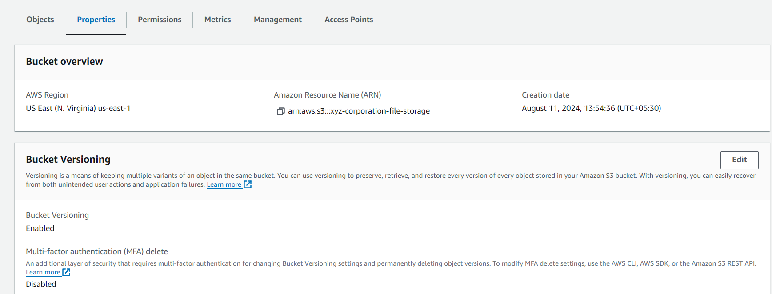

**Step 2: Re-upload Any 2 Files to Verify Versioning**

1. **Re-upload Files**:
   * Go back to the **Objects** tab in your bucket.
   * Click on the **Upload** button.
   * Click on **Add files** and select the two files you want to re-upload (e.g., one .txt file and one .bmp file).
   * Click **Upload**.

**Step 3: Verify Versioning**

1. **View Object Versions**:
   * After uploading, navigate back to the **Objects** tab.
   * Click on the **Show versions** button (you may need to enable this to see versioned objects).

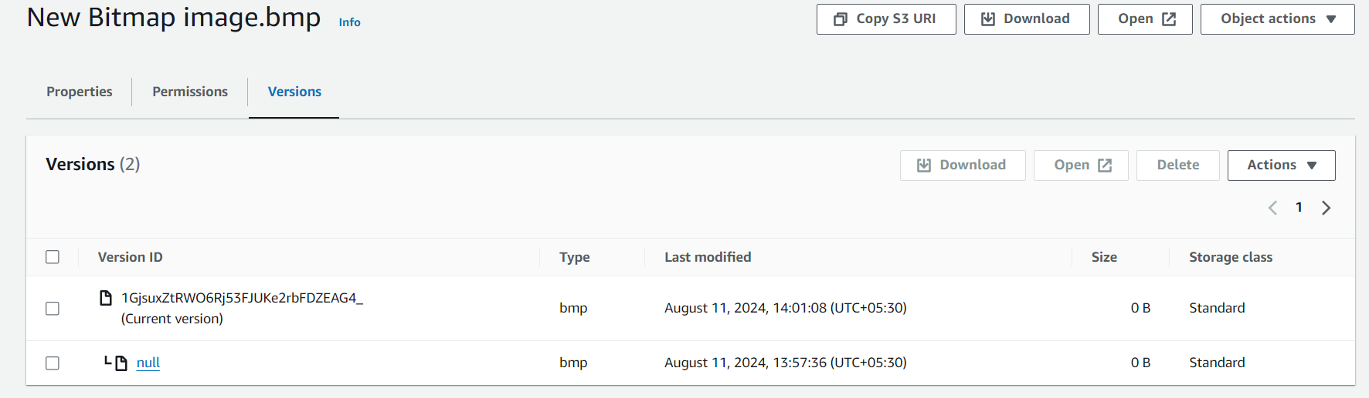

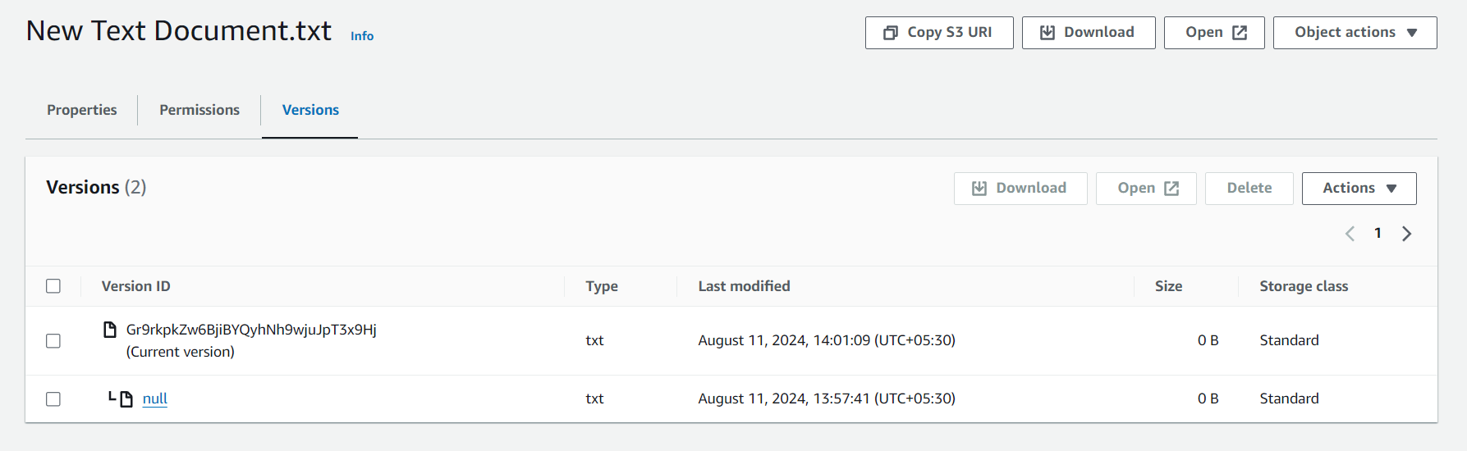

* + You should see both the original files and the new versions listed.

1. **Select Your Bucket**:
   * Click on the name of the bucket you created (e.g., xyz-corporation-file-storage).
2. **Enable Static Website Hosting**:
   * Go to the **Properties** tab.
   * Scroll down to the **Static website hosting** section.
   * Click on **Edit**.
   * Select **Enable**.
   * **Index document**: Enter index.html.
   * **Error document**: Enter error.html.
   * Click on **Save changes**.

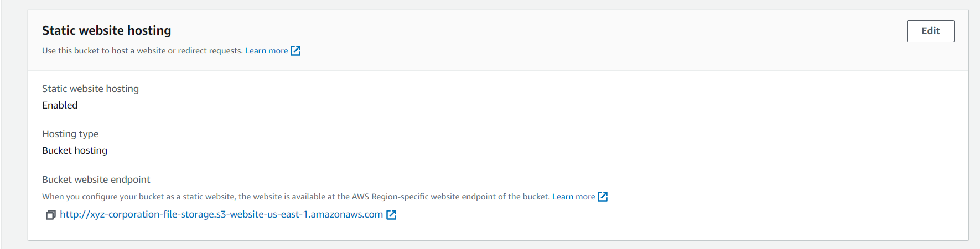

**Step 2: Upload the index.html and error.html Files**

1. **Upload Files**:
   * Go to the **Objects** tab in your bucket.
   * Click on the **Upload** button.
   * Click on **Add files** and select your index.html and error.html files.
   * Click **Upload**.

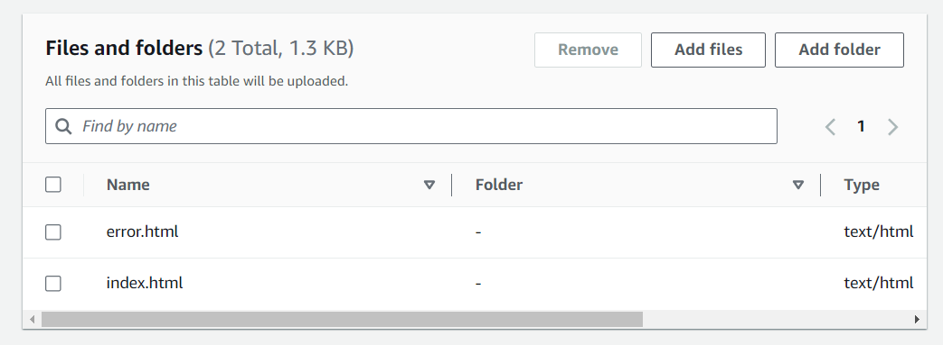

**Step 3: Set Permissions for Public Access**

1. **Set Permissions**:
   * After uploading the files, select each file and go to the **Permissions** tab.
   * Under **Public access**, click on **Edit**.
   * Select **Grant public read access to this object(s)**.
   * Click on **Save changes**.

**Step 4: Add Lifecycle Rules**

1. **Navigate to the Management Tab**:
   * With your bucket selected, go to the **Management** tab.
2. **Add Lifecycle Rule**:
   * Click on **Create lifecycle rule**.
   * Enter a **Rule name** (e.g., TransitionAndExpirationRule).
   * Choose **This rule applies to all objects in the bucket** (or you can specify a prefix if needed).
   * Click **Next**.
3. **Set Transition Rule**:
   * Check **Current version** and select **Transition to Standard-IA storage class**.
   * Set the transition to occur **60 days after creation**.
   * Click **Next**.

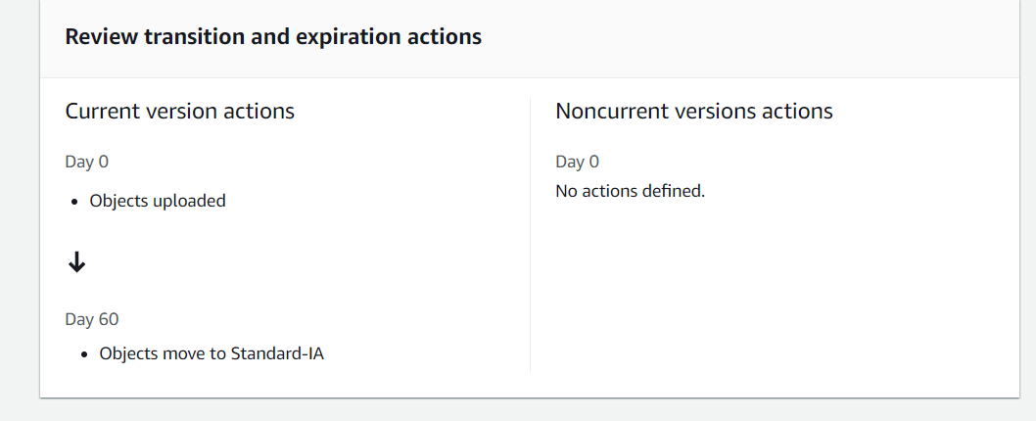

1. **Set Expiration Rule**:
   * Check **Current version** and select **Expire current version of objects**.
   * Set the expiration to **200 days after creation**.
   * Click **Next**.

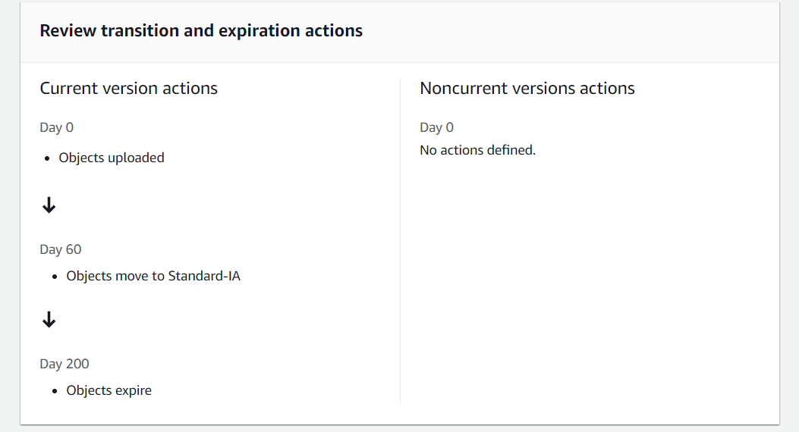

1. **Review and Create**:
   * Review the lifecycle rule settings.
   * Click on **Create rule**.

**Step 5: Verify Static Website Access**

1. **Access Your Website**:
   * Once everything is set up, go back to the **Properties** tab of your bucket.
   * Under **Static website hosting**, you'll find the **Bucket website endpoint**.
   * Copy and paste this URL into your browser to access your static website.

